Nepal College of Information Technology
Unit Test
Fall 2011
Program : BE IT Time : 2 hrs
Semester : Fall (III) FM : 70
Subject : Engineering Math-III PM : 35

- Candidates are requested to give their answer as far as practicable in their own words.
- The figure in the margin indicates the full marks
- Attempt ALL question
1. a) Show that
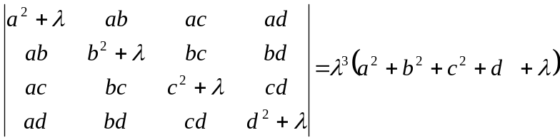
OR
Prove that 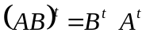 [7]
b) Solve
10x+4y-2z = -4
-3w-17x+y+2z=2
w + x + y = 6
8w-34x+16y-10z=4
by Gauss elimination method. [8]
2. a) Define rank of the matrix. Find the rank of the matrix
A = 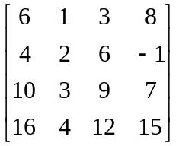 [8]
b) Define vector subspace. If
v = R³ be a vector space and
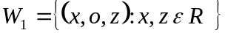
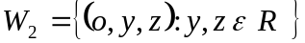
Show that 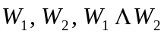 is a subspace of v. [7]
3. a) Define linear transformation. Check the linearity of the transformation if
T : R²→R³ be defined by T (x, y) = (x, y, xy) [7]
b) Find the eigen values and eigen vectors of the matrix
A = 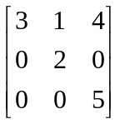 [8]
4. a) State and prove P-test. [8]
b) Discuss the convergence of the series
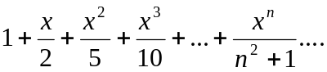 [7]
5. Test the convergence and divergence of the series (Any two) [2*5=10]
a) 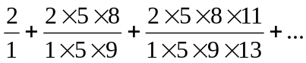
b) 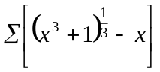
c) 